**Group 16**

**Group members:**

* **Taimoor sultan**
* **Ali hashim**
* **Ali muhammad**

**Assignment no 4**

**Data dictionary :**

| **Field** **Name** | **Description** | **Data** **Type** | **Size** | **Constraint** | **Default** **Value** |
| --- | --- | --- | --- | --- | --- |
| **User** | General user details |  |  |  |  |
| userID | Unique identifier for a user | Integer |  | Primary Key, Not Null |  |
| name | Name of the user | Varchar | 100 | Not Null |  |
| email | Email address of the user | Varchar | 150 | Not Null, Unique |  |
| **Transport** **Admin** | Details of the transport administrator |  |  |  |  |
| adminID | Unique identifier for transport admin | Integer |  | Primary Key, Not Null |  |
| role | Role of the admin | Varchar | 50 | Not Null |  |
| Driver | Details of the bus driver |  |  |  |  |
| **driverID** | Unique identifier for the driver | Integer |  | Primary Key, Not Null |  |
| licenseNo | Driver’s license number | Varchar | 50 | Not Null, Unique |  |
| name | Name of the driver | Varchar | 100 | Not Null |  |
| Student | Details of students |  |  |  |  |
| **studentID** | Unique identifier for a student | Integer |  | Primary Key, Not Null |  |
| name | Name of the student | Varchar | 100 | Not Null |  |
| rollNo | Roll number of the student | Varchar | 50 | Not Null, Unique |  |
| **Route** | Bus route details |  |  |  |  |
| routeID | Unique identifier for a route | Integer |  | Primary Key, Not Null |  |
| startLoc | Starting location of the route | Varchar | 150 | Not Null |  |
| endLoc | Ending location of the route | Varchar | 150 | Not Null |  |
| **Schedule** | Schedule details |  |  |  |  |
| scheduleID | Unique identifier for a schedule | Integer |  | Primary Key, Not Null |  |
| time | Time of the schedule | Time |  | Not Null |  |
| **Bus** | Bus details |  |  |  |  |
| busID | Unique identifier for a bus | Integer |  | Primary Key, Not Null |  |
| busNumber | Number assigned to a bus | Varchar | 50 | Not Null, Unique |  |
| **Request** | Transport request details |  |  |  |  |
| requestID | Unique identifier for a request | Integer |  | Primary Key, Not Null |  |
| status | Status of the request (Pending/Approved/Rejected) | Varchar | 50 | Not Null |  |

**System sequence diagram :**

Taimoor sultan

Use cases:

* Update record
* Delete record
* View record
* Add record

**Update record**

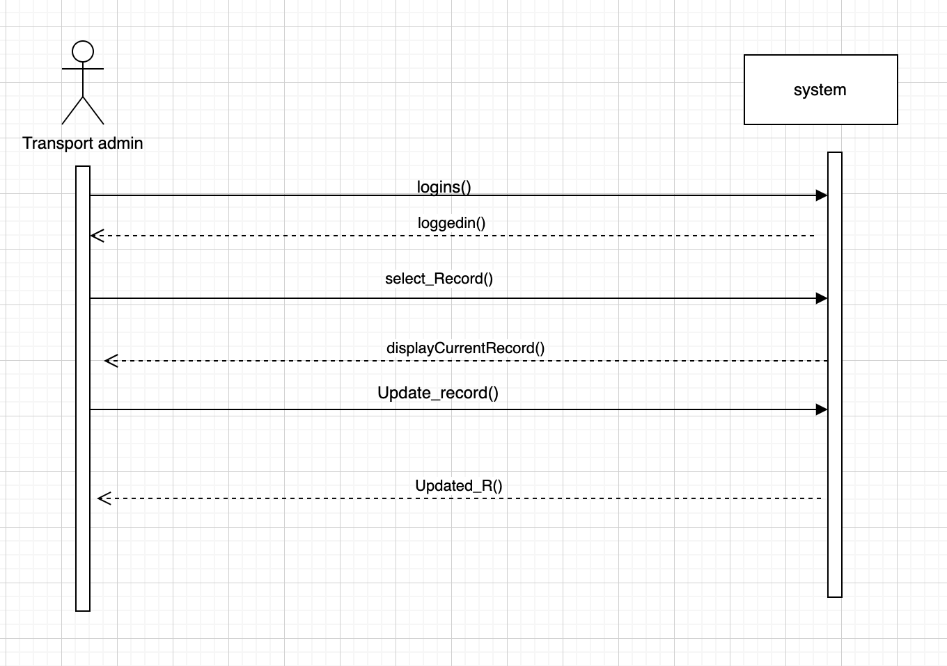

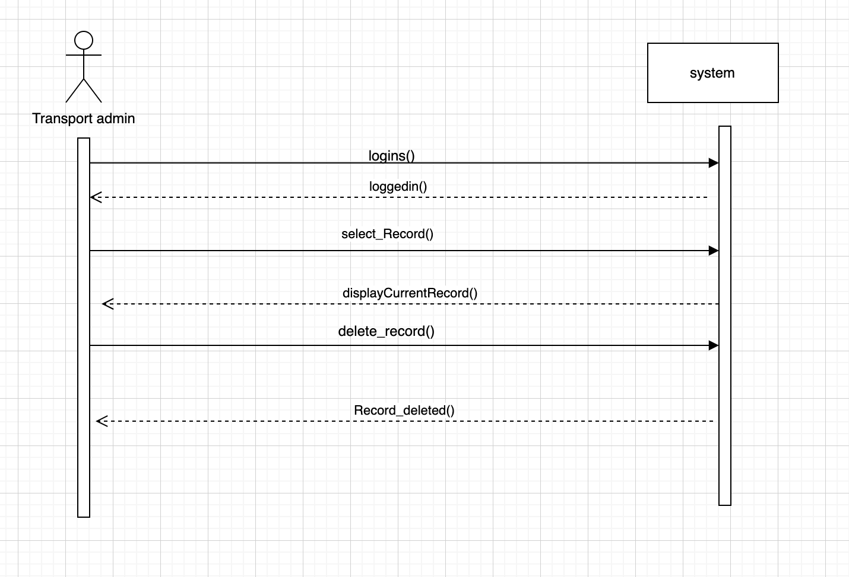

**View record**

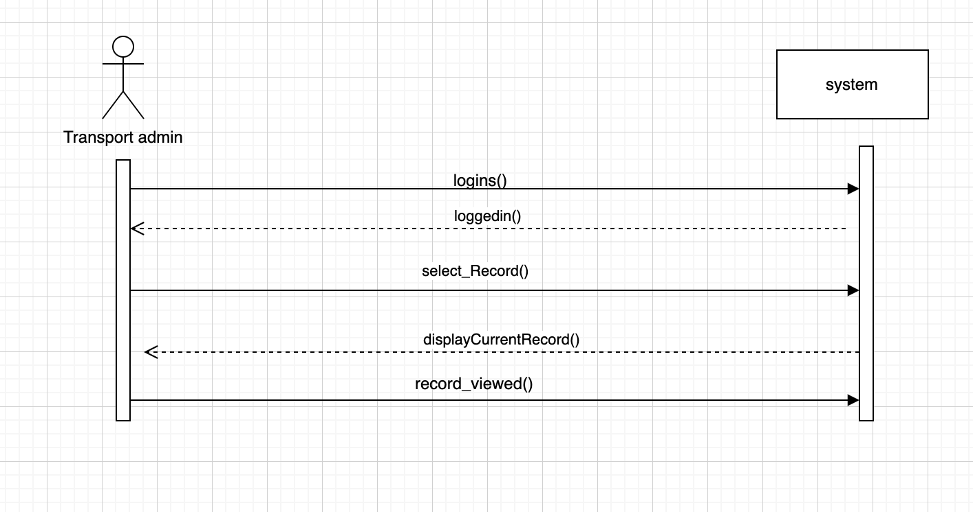

**Add record**

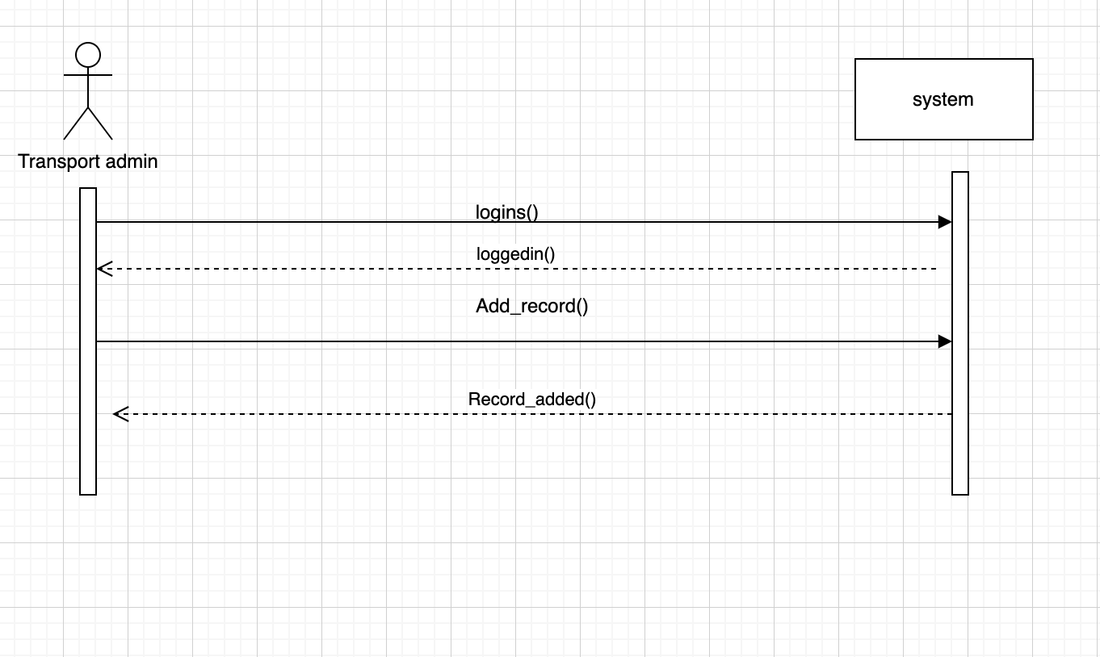

**Ali Hashim**

* **View bus schedule**
* **Check available bus**
* **Add route**
* **Delete route**
* **View assigned route**

**View bus schedule**

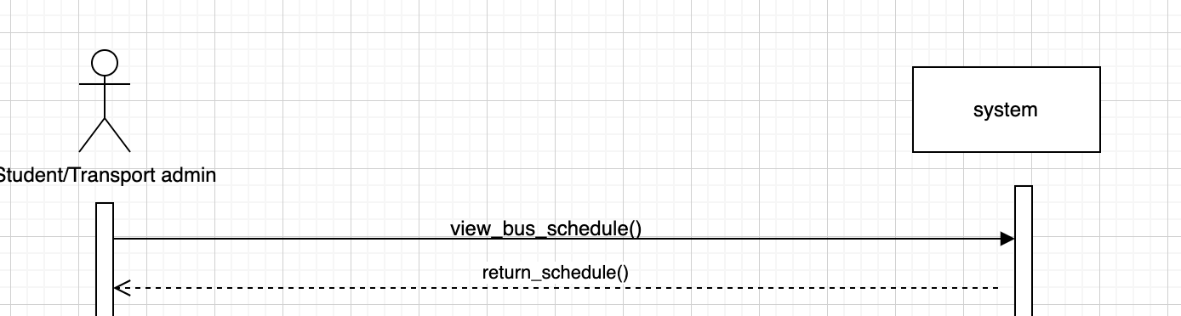

**Check available bus**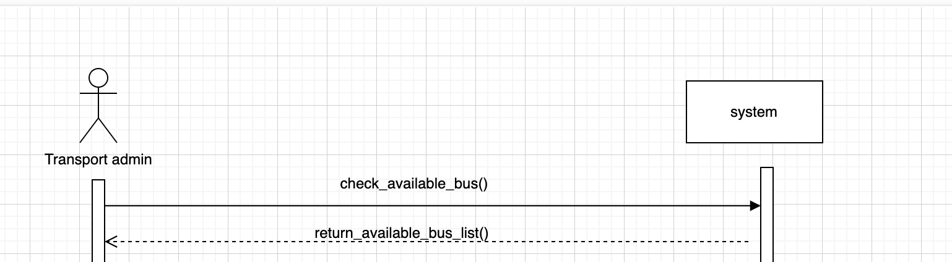

**Add route**

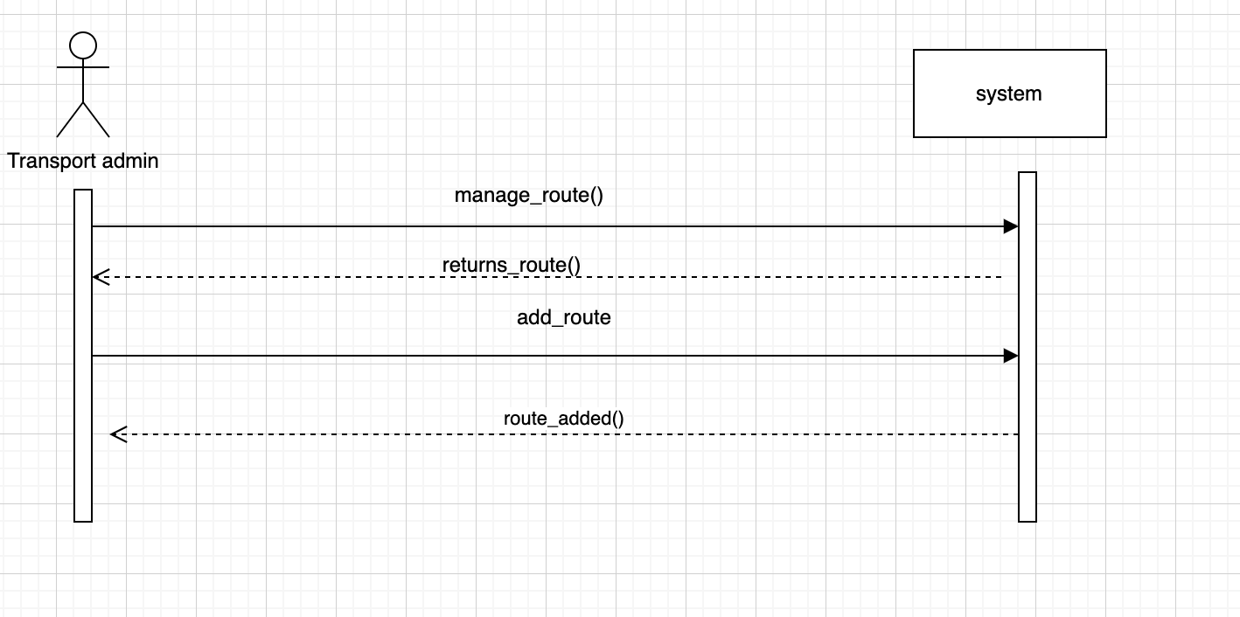

**Delete route**

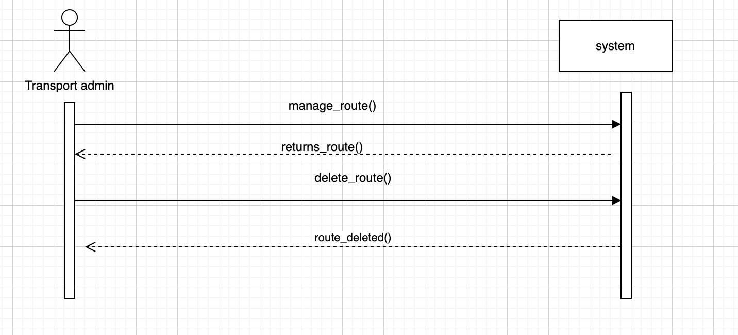

**View assigned route**

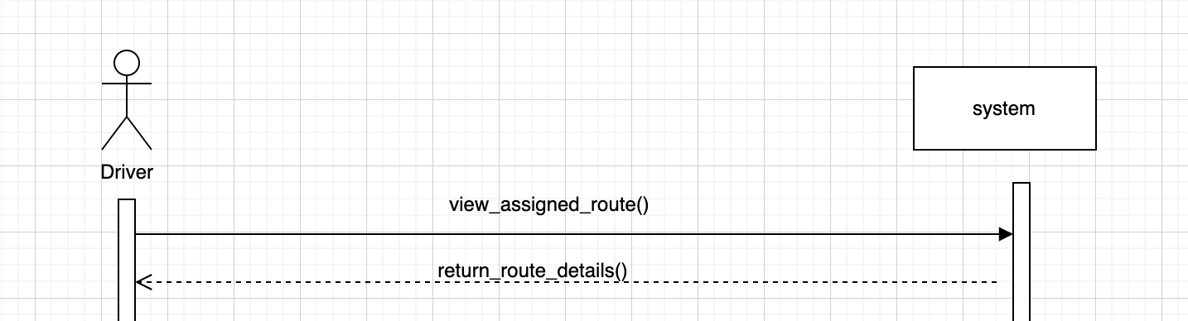

**Ali Turi**

* **Confirm Timing**
* **Update Record**
* **Request Vehicle**
* Confirm Pickup Location

**Confirm Timing**

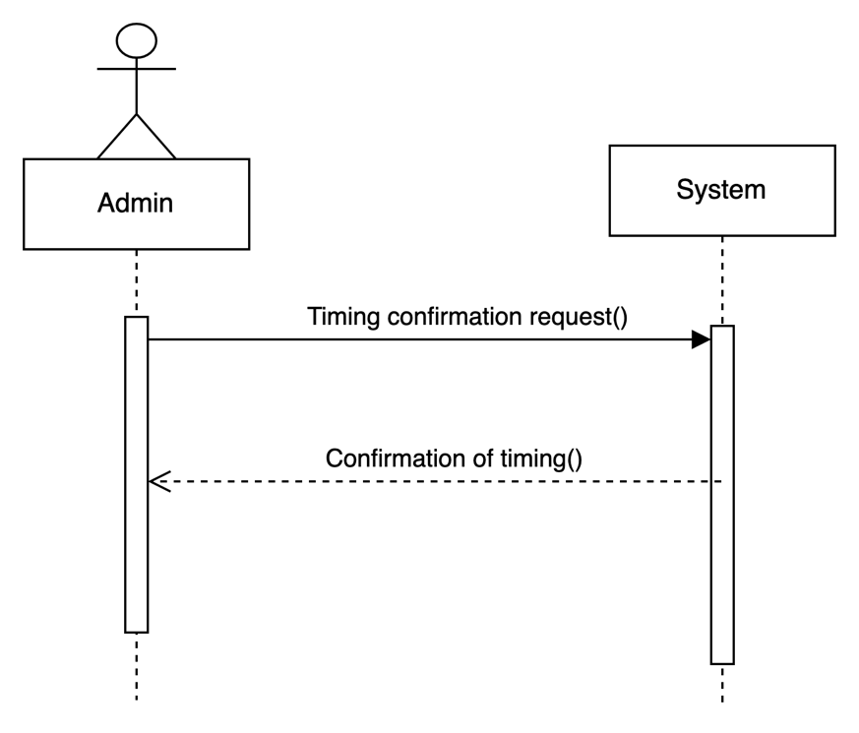

**Record Update Status**

